5th SKDUN EUROPEAN SHOTOKAN KARATE CHAMPIONSHIP
and
5th SKDUN Kohai European Cup

SHOTOKAN KARATE-DO OF UNITED NATIONS
SKDUN OF LATVIA
With the support of
Town of Daugavpils
have the honour and pleasure to invite you to the
5th SKDUN Gichin Funakoshi European Shotokan Karate Championship
and to the
5th SKDUN Kohai European Cup that will take place in Daugavpils-Latvia
on 17 - 19 April 2015

Place of competition:
Daugavpils Olympic Halle, street Stadiona 1, Daugavpils, Latvia

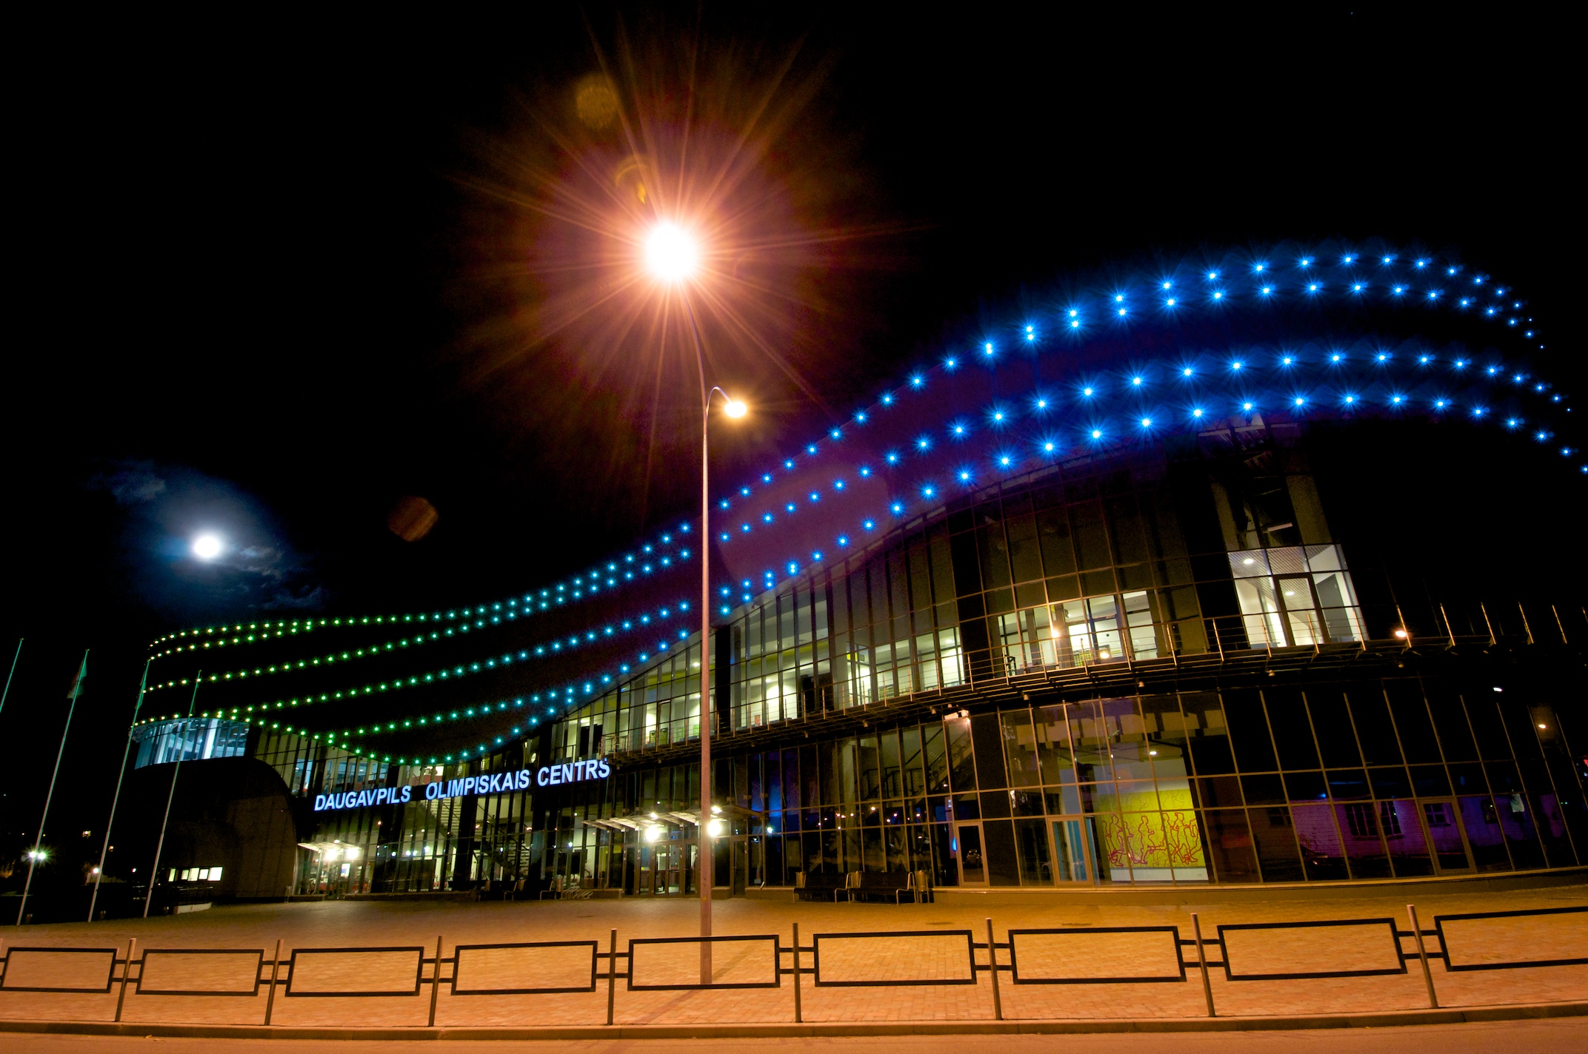
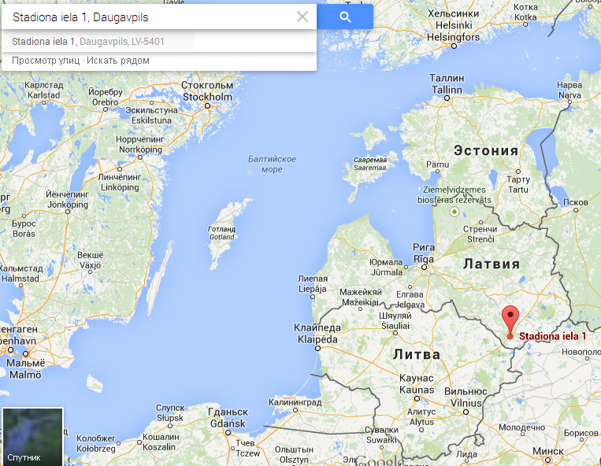

Board of organizers:

Aurel Patru
President of Shotokan Karate Do of United Nations
Email: aurelpatruskdun@gmail.com, Phone: 0040722385780

Colin Putt
Chief Referee of Shotokan Karate Do of United Nations
Email: puttcolin@aol.com, Phone: 00447968061887

Aleksandr Balabko (English speaking person), Responsible for the organization,
Organizing Committee
Email: skdunlv@gmail.com Phone: mob. 00371 29738747

Aleksejs Bistrovs
President of Latvian JKA karate-do federation and SKDUN of Latvia
Member of the Organizing Committee

Sergejs Ivanko
SKDUN Latvia, SOCHIN karate klub (Daugavpils, Latvia)
Visas, Technical Coordinator of Organizing Committee
magicas@dautkom.lv
mobile 00371 29151579

Accommodation and lunches:
The members of the SKDUN Board will have free accommodation (with breakfast and dinner included, insurance and tourist taxes) and free lunch in restaurant at the Sport Hall according to preselected menu. The members of the Board and technical support persons will be accommodated at hotel in very Centre of Daugavpils, 10 minutes walking from the Sport Hall.

SKDUN and the organizer will support the cost of accommodation only for the referee registered by Sensei Colin Putt (maximum 3 days x 25Euro/day, Total: 75 Euro)

Referees don’t have accommodation in a special hotel, they need to stay with their teams.
If they are on their own, they need to contact the organizer for accommodation. All the registered referees will have free lunch in Restaurant of Sport Hall. (Board + Referees + Technical staff 100 lunch vouchers per day.). They will be given the appropriate vouchers for every free lunch.

The whole accommodation process will be organised by SKDUN Latvia.
The list of hotels, capacities and the special SKDUN prices:

Park Hotel „Latgola”  Gimnāzijas 46 St. Daugavpils,  266 persons | Standart double – 66 rooms  Business class for 3 persons – 44 rooms | 35 Euro per person per night (breakfast incl.)
Hotel Aleksandria  Stacijas St 65/67,  Daugavpils  20 persons | Double rooms – 8 rooms  Studio flat – 4 persons – 1 room | 25 Euro per person per night (breakfast incl.)
BIPLAN hotel  18.Novembra St. 50 ,  Daugavpils  44 persons | Double rooms – 22 rooms | 25 Euro per person per night (breakfast incl.)
Guest house „Liepajas”  Liepajas St. 72,  Daugavpils  40 persons | 4 person rooms – 10 rooms | 60 Euro per 4 person per night (without breakfast) / in each room is kitchen.
Dinaburg hotel,  Dobeles 39 St.,  Daugavpils  83 persons | One bed room – 23 rooms  Double room – 24 rooms  Triple room – 4 rooms | 25 Euro per person per night (breakfast incl.)
LEO hotel,  Kraslavas 58 St.,  Daugavpils  10 persons | One bed room – 4 rooms  Double room – 1 room  Triple room – 1 room | 25 Euro per person per night (breakfast incl.)
Duets hotel,  Precu 1 St.,  Daugavpils  40 persons | One bed room – 4 rooms  Double room – 5 rooms  2x2 persons – 1 room  LUX 3 persons – 4 rooms | 25 Euro per person per night (breakfast incl.)
Erfolg hotel,  Nometņu St. 25a,  Daugavpils  30 persons | 5 person hospis – 4 rooms  Double room – 5 rooms | 15 Euro per person per night (breakfast incl.)  25 Euro per person per night (breakfast incl.)
Olimpija hotel,  Valkas St. 2u,  Daugavpils  24 persons | One bed room – 1 room  Double room – 7 rooms  Triple room – 3 rooms | 25 Euro per person per night (breakfast incl.)
Rebir hotel,  Vienibas St. 19,  Daugavpils  10 persons | Double room – 5 rooms | 25 Euro per person per night (breakfast incl.)
Sport camp „Jantariks”,  Daugavpils  160 persons | 4 Persons room – 40 rooms | 10 Euro per person per night (without breakfast)

All the accommodation activities / bookings have to be coordinated with Aleksejs Bistrovs. Email: skdunlv@gmail.com mobile Phone: 00371 29738747 .We kindly ask all national teams to declare, as soon as possible, the expected
number of participants and special requests concerning the accommodation and
prices in order to enable early reservation and better conditions.
- Early bird registration starts from 28 February and will end on 10 April 2015. With early bird registration we can guarantee the special SKDUN prices.
- For the registrations between 11 April and 17 April 2015 the prices would be 10% higher.

How to arrive at Daugavpils, Latvia?
Airports:
1. Airport Vilnus is the nearest one located approximately 180km from Daugavpils.
Transfer from/to Airport Vilnus to/from the accommodating hotel will be organised by the Organisation
Committee with two way transfer, cost maximum of 20 EUR per person and transfer for SKDUN Board and VIP persons will be for free.
All competitors that would like to use the provided transportation are kindly invited to inform the organiser
about their flights details in order to facilitate the organisation. Contact Sergejs Ivanko email: magicas@dautkom.lv
mobile 00371 29151579
At your arrival at the airport you will find a contact point: one person will accompany you to the Hotel or Sport Hall to make the registration.

Visas
Countries who need Visas must contact Sergejs Ivanko (English speaking person), Responsible for the organisation, SKDUN Shotokan Karate, Visa Organising Committee
Sergejs Ivanko email: magicas@dautkom.lv mobile 00371 29151579

Awards
Awards for the World championship will be diplomas for all competitors.
In individual kata events, awards will be diplomas, medals and trophy for 1st, diplomas and medals
2nd and 3rd places.
In kumite events (individual and team), awards will be diplomas, medals and trophies for 1st places,
diplomas and medals for 2nd and 3rd places, the team events awards will also include medals
for team members.
Competition fees
Each individual event: 20€ per person
Each team event: 45€ for team
*Also will be organized ONLINE VIDEO LIVE TRANSLATION @ web page www.skdun.lv

Short schedule (you will receive a more detailed schedule by 13 April 2015)
Friday, 17 April
12:00 to 21:00 - registration and recording of the competitors by the team manager or delegated
person (competitors need not attend, just the delegated person / manager)
Saturday, 18 April
09:00 to 21:00.- competition
Sunday, 19 April
09:30. to 17:00.- competition !!!

DEADLINE FOR RECEIPT OF ENTRY FORMS: 02 April 2015
Please send the entry forms to Sensei Aurel Patru – SKDUN President:
aurelpatruskdun@gmail.com

DEADLINE FOR RECEIPT OF ENTRY FORMS FOR COMPETITION OFFICIALS
(REFEREES, JUDGES, MANAGERS, COACHES, INTERPRETERS,
PHOTOGRAPHERS
AND TEAM DOCTORS: 25 March 2015

Please send the entry forms to Sensei Colin Putt - Chief Referee:
puttcolin@aol.com

(We cannot guarantee entry to the competitions for applications received
after the deadlines)

Categories for
5th SKDUN European Shotokan Karate Championships
Competition only for advanced belts, 3 kyu – Dan, (brown belt + black belt)

KATA INDIVIDUAL
CHILDREN’S (10 – 11 years): Boys / Girls
MINICADETS (12 – 13 years): Boys / Girls
CADETS (14 – 15 years): Boys / Girls
JUNIORS (16 – 17 years): Boys / Girls
YOUTHS (18 – 20 years): Men / Women
SENIORS (21 – 39 years): Men / Women
VETERANS (40 - 49 years): Men / Women
VETERANS (over 50 years): Men / Women

Kata rules for the group 3 Kyu – Dan: By point system (elimination rounds and final rounds).
The competitors of each category will compete in the elimination rounds down to 8 competitors
(two competitors at the same time, AKA / SHIRO).
In semi-finals, these 8 competitors will perform Tokui kata (their choice from the approved list),
then 4 competitors with the highest scores will perform a different Tokui kata in the final round (for
medal places).

Children (10 – 11 years), Minicadets (12 – 13 years) and Cadets (14 – 15 years) will perform in
the elimination rounds Sentei kata: Bassai Dai and Jion (referee choice) and in the semi-final
the top 8 competitors can perform Tokui kata, according with the approved kata list and competitors range (you will find in the attached document from the rule book). For the final round (top 4
competitiors) will perform Tokui kata (not the same kata as in the semi-final).

Juniors (16 – 17 years), Youths (18 – 20 years), Seniors (21 – 39 years) and Veterans, will perform in the elimination rounds Sentei kata: Bassai Dai, Enpi, Jion and Kanku
Dai (referee choice). In the semi-final the top 8 competitors can perform Tokui kata, according with the approved kata list and competitors range (you will find in the attached document from the rule book). For the final round (top 4 competitiors) will perform Tokui kata (not the same kata as in the semi-final).
In the case of a draw in the semi final and final rounds, competitors must perform a different kata.
Limit of participation: Max of 6 competitors per country per category. The organising country can
register a total of 7 competitors.

KATA TEAM
Kata teams can include ONE 5 kyu or 4 kyu (blue belts), and 2 advanced grades (3 kyu - Dan)
CADETS (12 – 15 years): Kata team boys / Kata team girls / Kata team mixed
(Children can participate in cadet team kata category: Cadet Team Kata, must include at least 2
cadets)
JUNIORS (16 – 20 years): Kata team men / Kata team women / Kata team mixed
(Cadets can participate in junior team kata category: Junior Team Kata , but must include at least
2 juniors)
SENIORS (over 21 years): Kata team men / Kata team women / Kata team mixed
(Juniors can participate in senior team kata category: Seniors Team Kata , but must include at
least 2 seniors)

Kata team rules: By point system.
In elimination rounds: Free kata (Tokui).
In the Final Round (4 Teams): A different Kata must be performed than in the elimination rounds.
In the case of a draw, teams must perform a different kata than performed in the previous rounds.
Limit of participation: Max of 2 teams per country are accepted in each category

KUMITE INDIVIDUAL
CHILDREN (10 – 11 years)
Boys - 35 kg / Boys + 35 kg / Girls: Open
MINICADETS (12 – 13 years)
Boys -40 kg / -45 kg / -50 kg / +50 kg; Girls -45 kg / +45 kg
CADETS (14 – 15 years)
Boys -50 kg / -58 kg / -65 kg / +65 kg; Girls -52 kg / +52 kg
JUNIORS (16 – 17 years)
Boys -55 kg / - 62 kg / -70 kg / +70 kg; Girls -57 kg / +57 kg
YOUTHS (18 – 20 years)
Men -60 kg / -68 kg / -75 kg / +75 kg; Women -60 kg / +60 kg
SENIORS (over 21 years)
Men -65 kg/ -70 kg / -77 kg / -85 kg / +85 kg; Women -55 kg / -60 kg / +60 kg
VETERANS (40 – 49 years): Open (if there will be many competitors we will divide on two weight categories)
VETERANS (over 50 years old): Open
Veterans can also participate in Seniors events
MEN ALL OPEN (seniors and youths), over 18 years old
WOMEN ALL OPEN (seniors and youths), over 18 years old
For all age groups the competition is run on Ippon Shobu (2 wazari or 1 Ippon).
The time for each match: 1 minute and 30 seconds for children and minicadet categories.
2 minutes for cadet, junior, youth, senior and veterans categories.
Final of the seniors and veterans individual kumite to be Sanbon Shobu (3 minutes).
Limit of participation: 6 competitors per country, the organising country can register a total of 7
competitors

Sunday.
The last event will be the prestigious Masters competition.
Each country can nominate one Female and one Male competitor over 18 years of age that
will compete in Kata and Kumite for the ultimate title of Grand Champion.
Nominations to be submitted on Saturday evening.

KUMITE TEAM
(the kumite team can include one 5th or 4th kyu grade (blue belts), but must include at least 4 advanced grades
- brown or black belt - out of a 5 person team or 2 advanced grades out of a 3 person team)
CADETS (12 – 15 years)
Boys - 55 kg (3 + 1 reserve) / Boys + 55 kg (3 +1 reserve); Girls Open (3 + 1 reserve)
Mixed Open, 5 competitors (3 boys + 2 girls) + 2 reserve), each match: 1 minute and 30 seconds
JUNIORS (16 – 20 years) (Cadets can participate in junior kumite team category (one per team):
Juniors Kumite Team - majority must be of the category age and grade.
Junior male team open: 3 + 1 reserve. Junior female team open: 3 + 1 reserve.
Mixed Open: 5 competitors, 3 male + 2 female + 1 male and 1 female reserve.
Each match: 2 minutes
SENIORS (over 21 years) (Juniors can participate in senior team event category (one per team) :
Seniors Kumite Team -
Mens Open: 5 + 2 reserve. Womens Open: 3 + 1 reserve.
Mixed Open: 5 competitors, 3 male + 2 female + 1 male and 1 female reserve.
Each match 2 minutes for seniors.
For all the kumite team events, the competition is run on Ippon Shobu (2 wazari or 1 Ippon)
Limit of participation: 2 teams per country are accepted in each team kumite category.

5th SKDUN European Cup
Competition for lower grades (9-4 kyu)

KATA INDIVIDUAL
KIDS (8 – 9 years): Boys 9 – 7 Kyu, Boys 6 – 4 Kyu, Girls 9 – 7 Kyu, Girls 6 – 4 Kyu
CHILDREN (10 – 11 years): Boys 9 - 7 Kyu, Boys 6 - 4 Kyu, Girls 9 - 7 Kyu, Girls 6 - 4 Kyu
MINICADET (12 – 13 years): Male 9 - 7 Kyu, Male 6 - 4 Kyu, Female 9 - 7 Kyu, Female 6 - 4 Kyu
CADET (14 – 15 years): Male 9 - 7 Kyu, Male 6 - 4 Kyu, Female 9 - 7 Kyu, Female 6 - 4 Kyu
JUNIORS (16 – 17 years): Male 9 - 7 Kyu, Male 6 - 4 Kyu, Female 9 - 7 Kyu, Female 6 - 4 Kyu
SENIORS (over 18 years): Male 9 - 7 Kyu, Male 6 - 4 Kyu, Female 9 - 7 Kyu, Female 6 - 4 Kyu

Kata rules: By point system. Only one elimination round, kata chosen by the referee.
Two competitors at the same time (AKA / SHIRO) the best 8 scoring competitors pass to the final
round.
Final round (by point system) – Free (Tokui) kata.
Elimination Kata: for the group 9 - 7 kyu between Taikyoko Shodan and Heian Shodan.
Tokui kata between Taikyoku Shodan and Heian Sandan.
For group 6 - 4 kyu between Heian Shodan, Heian Nidan and Heian Sandan.
Tokui Kata between Heian Shodan and Tekki Shodan (no other kata are allowed).
In the case of a draw they must perform a different kata.
After the registration (deadline is 1 October) the organiser can divide kyu groups (if there are too
many participants) and they will inform you about any new kyu group categories by the 4 October.
No limit of participation.

KATA TEAMS CHILDREN (8 – 12 years): Kata team boys/ Kata team girls / Kata team mixed
( no limit of participation) - brown belts can participate too (no limit of kyu grade)
In elimination rounds for kata teams: Free kata (Tokui) In the Final Round (4 Teams): different
Kata than in the elimination rounds. In the case of a draw, they can repeat kata.

KUMITE INDIVIDUAL
KIDS (8 – 9 years) - SANBON KUMITE
Boys: 9 – 7 kyu (different kg categories) ; Girls: 9 – 7 kyu (different kg categories)
Boys: 6 – 4 kyu (different kg categories) ; Girls: 6 – 4 kyu (different kg categories)
CHILDREN (10 – 11 years) – SANBON KUMITE
Boys: 9 – 7 kyu (different kg categories) ; Girls: 9 – 7 kyu (different kg categories)
Boys: 6 – 4 kyu (different kg categories) ; Girls: 6 – 4 kyu (different kg categories)

In Sanbon kumite: Tori attack: jodan oi zuki +chudan oi zuki +mae geri,
Uke block: Jodan age uke + chudan soto uke + gedan barai.
NOTE: Refer to the rule book for implicit instruction guide, most you tube etc video are not precise
and or correct.
Referees will judge SANBON KUMITE by the flag system

MINICADETS (12 – 13 years) – JYU KUMITE
Boys: Up to 40 kg / 41 - 45 kg / 46 - 53 kg / 53 kg +. Girls: Up to 45 kg / 45 kg +
CADETS (14 – 15 years) – JYU KUMITE
Male: Up to 60 kg / 60 kg +. Female: Up to 50 kg / 50 kg +
JUNIORS (16 – 17 years) – JYU KUMITE
Male: Up to 65 kg / 65 kg +. Female: Open.
SENIORS (over 18 years) – JYU KUMITE
Male: Up to 75 kg / 75 kg + Female: Open

The registration deadline is the 2 April 2015, the organiser can divide weight categories if there
are to many participants in any category and they will inform you of any changes.

Time for Jyu kumite matches for Minicadets and Cadets will be 1 minute and 30 seconds.
All other categories will be 2 minutes.

The Jyu kumite competition is run on SKDUN rules – Ippon Shobu (2 wazari or 1 Ippon).
No limit of participation.

